Review of Low Barrier Service Models in Downtown Spokane
  - Memorandum to File | Gavin Cooley, SBA President | 18, 2026

Core finding: Low barrier services remain necessary, but legacy models that operate as isolated, attraction-based service points in highly fragile downtown locations warrant review of location and, where needed, redesign toward more integrated treatment, stabilization, shelter navigation, and neighborhood stewardship.

Introduction
This memorandum reviews the role of longstanding low barrier service models in downtown Spokane, with particular attention to Shalom Ministries. House of Charity and the former City Gate remain part of the broader downtown context, but they are addressed primarily in the attachments. The focus here is narrower. It is whether Shalom's current structure, location, and service model should be reconsidered in light of changed conditions and an immediate opportunity to shape its next phase.
The central question is different. It is whether the structure, location, and delivery model of certain low barrier services should now be reassessed in light of changed conditions, especially the rise of synthetic opioids, the severity of the current overdose environment, the increasing complexity of untreated behavioral health conditions on the street, and the visible strain on downtown Spokane.
The principal conclusion of this review is that low barrier services meet a real and continuing need in the community, and may in some respects be more important than ever before. But standalone, place bound, and weakly integrated service models in the urban core are increasingly difficult to defend unless they are closely connected to treatment, stabilization, shelter navigation, and broader neighborhood management strategies.
This memorandum focuses primarily on Shalom Ministries for two reasons.
- Shalom appears to be at an immediate decision point. It is considering a move, and Shalom has publicly stated that New Community Church, the building where it operates, has been put up for sale.
- This moment presents an opportunity not simply to relocate, but to consider how Shalom's mission might be carried out in a way that is more integrated, more sustainable, and better aligned with present conditions.
Comparative background on selected downtown Spokane providers is included in Attachments A and B. Those materials are intended to make clear that downtown Spokane’s low barrier and drop-in service landscape is varied, and that not all such programs are similarly situated or produce the same neighborhood effects. The present memorandum focuses on Shalom Ministries because it is at an immediate decision point and because its location, service model, and surrounding context present a particularly timely opportunity for review.

Background and purpose
For many years, Spokane's charitable response to homelessness and extreme poverty developed in a context shaped by older drug markets, lower overdose lethality, and a service population that, while often deeply vulnerable, was generally less affected by the current combination of fentanyl addiction, methamphetamine use, severe psychiatric destabilization, and chronic street exposure.
That context has changed significantly. The present street environment is not simply a continuation of prior conditions. It is shaped by a different drug supply, different risk profile, and different level of public disorder. As a result, service models that may once have relieved suffering without generating comparable levels of secondary harm now warrant renewed examination.
This is not an argument against charity, low barrier access, or outreach to highly vulnerable individuals. It is an argument for reviewing whether current methods still serve their intended humanitarian purpose under present conditions, and whether they do so in a way that is compatible with the health of the surrounding community.

Background: Shalom Ministries
Shalom Ministries traces its Spokane roots to meal service work in the 1970s and 1980s and became a separate nonprofit in 1994. It currently operates at 518 West 3rd Avenue and reports serving more than 84,000 meals annually. Publicly available materials also describe a Pathways program through which community volunteers who are accepted into the program become core team members and receive job and life skill training, case management, mentoring, housing assistance, and a monthly stipend. Earlier reporting on the launch of Pathways in 2015 described it as a program offering job training, counseling, a small stipend, and temporary housing in exchange for work with Shalom’s meal and support functions. At the same time, the publicly available information does not make clear the current scale of Pathways, the number of participants it serves, or the degree to which it operates as a central rather than secondary part of Shalom’s overall ministry. The issue has become more immediate because Shalom has publicly stated that New Community Church, where it operates, has put the building up for sale and that the ministry needs a new home. That makes this an especially timely moment to consider not only where Shalom should go next, but how it might evolve while doing so.
Further comparative background on House of Charity, the former City Gate, and other selected downtown providers is included in Attachments A and B. The present memorandum focuses on Shalom because it combines an immediate relocation decision, adjacency to Lewis and Clark High School, a high volume adult meal centered model, and a timely opportunity to rethink how its next phase should be structured.
The question is not whether Shalom has done valuable work. It clearly has. The question is whether its current operational form remains well suited to present conditions.

Importance of location and downtown context
Location is not incidental to this analysis.
Shalom Ministries operates at 518 W. 3rd Avenue, essentially one block from Lewis and Clark High School, located at 521 W. 4th Avenue. That proximity raises obvious concerns. A service model that regularly contributes to congregation of highly unstable individuals in immediate proximity to a major downtown high school, where a significant portion of the student population is highly vulnerable and often experiencing housing instability, necessarily raises not only service delivery questions, but also questions of neighborhood stewardship, student exposure, public safety, and the visual normalization of severe addiction near adolescents.
A related local example reinforces the importance of location. For many years, Volunteers of America operated its Crosswalk youth shelter at 525 W. 2nd Avenue in downtown Spokane. In explaining its move east, VOA stated that the downtown location had become increasingly dangerous and emphasized the value of a setting away from the stress of downtown, closer to schools, green space, health services, and other supports. That does not mean downtown services are never appropriate. It does, however, illustrate a critical point: service providers themselves recognize that surrounding street conditions and neighborhood context materially affect outcomes. If those considerations matter for a youth shelter, they also matter when evaluating low barrier service configurations near schools, fragile commercial corridors, and already burdened parts of downtown.
There have also been reports of overdose deaths in the parking lot of New Community Church, where Shalom operates, further underscoring that the ministry is now functioning in a far more dangerous environment than in earlier decades.
Another reason the present memorandum focuses on Shalom Ministries is that it appears to draw one of the highest acuity adult street populations into the downtown core, including a disproportionate number of single adult men experiencing severe addiction, behavioral instability, and chronic street exposure. That fact should not be read as a criticism of the people being served, who are among the most vulnerable in the community. It does, however, make Shalom materially different from providers serving more bounded or specialized populations such as seniors, youth, or women. The practical issue is the visible scale and intensity of the congregation that forms around the site, including observed open drug use, immediately adjacent to a major downtown high school.
These location issues matter all the more because downtown Spokane is not merely experiencing ordinary cyclical stress. By many measures, and in the view of many long time observers, downtown is in a deeper crisis than at any point in living memory. Downtown struggled in earlier periods, including the late 1990s, but the present convergence of vacancy, visible disorder, public drug use, behavioral instability, and declining confidence appears significantly more severe and likely harder to reverse.
Under these circumstances, it is no longer sufficient to treat the location of service concentrations as secondary. In the current environment, location is part of the intervention model itself.
A local case study further illustrates the importance of location. Compassionate Addiction Treatment, or CAT, previously operated at 168 S. Division Street, near Second Avenue and Division, in one of the most visibly burdened parts of Spokane's downtown. CAT later moved to 960 E. 3rd Avenue, near Arthur Street, on the east edge of downtown with Interstate 90 immediately to the south. Public materials indicate that CAT continues to carry out its mission at the new site, including outpatient treatment, medication for opioid use disorder, peer support, housing and employment case management, and navigation services. Anecdotally, the program appears to be functioning more effectively at the new location. The significance of the move is not that treatment should be pushed away from public view, but that thoughtful siting can preserve access to care while reducing collateral neighborhood harm.
The CAT example suggests the value of locations that remain accessible but are more buffered from schools, dense commercial corridors, and fragile neighborhood gateways. Sites with a similar physical logic, including areas near the former Costco building or an expanded footprint around the Cannon Street Shelter area, merit serious consideration, provided Spokane avoids simply recreating another overconcentrated service corridor. More broadly, CAT’s move illustrates a central point of this memorandum: services for vulnerable populations should be judged not only by the quality of the care they provide, but also by whether their location unnecessarily compounds harm in parts of the city already carrying a disproportionate share of the burden.

Changed conditions in the fentanyl era
The fact that Shalom Ministries is actively considering a future move makes this review especially timely. This is not simply a real estate question. It is an opportunity to examine how location, service design, partnerships, and neighborhood compatibility should be aligned in the age of fentanyl.
It is also an opportunity for Shalom to reposition the ministry positively. A shift away from relative isolation and toward a more integrated model could strengthen outcomes, improve public credibility, and create a more compelling fundraising narrative, one centered not on retreat from mission but on faithful adaptation of mission to present conditions.
The most important factor driving this review is the degree to which street conditions have changed.
The current drug environment is not simply a more intense version of prior homelessness related challenges. It is structurally different. The rise of synthetic opioids, especially fentanyl, together with widespread methamphetamine use and associated behavioral deterioration, has altered both the needs of the population being served and the risks generated by unmanaged street congregation.
Spokane County's overdose data illustrate the magnitude of this change. The county recorded 80 overdose deaths in 2019, compared with 346 deaths in 2024 and 344 preliminary deaths in 2025. Local reporting indicates that in 2024 more than 80 percent of overdose deaths involved an opioid, many involving fentanyl.
As reflected in the attached comparative graphic, Spokane is not dealing with an ordinary local increase. It is operating near the top of the national distribution among larger jurisdictions, which reinforces the broader point of this memorandum: Spokane's overdose crisis is severe by any reasonable comparative standard.

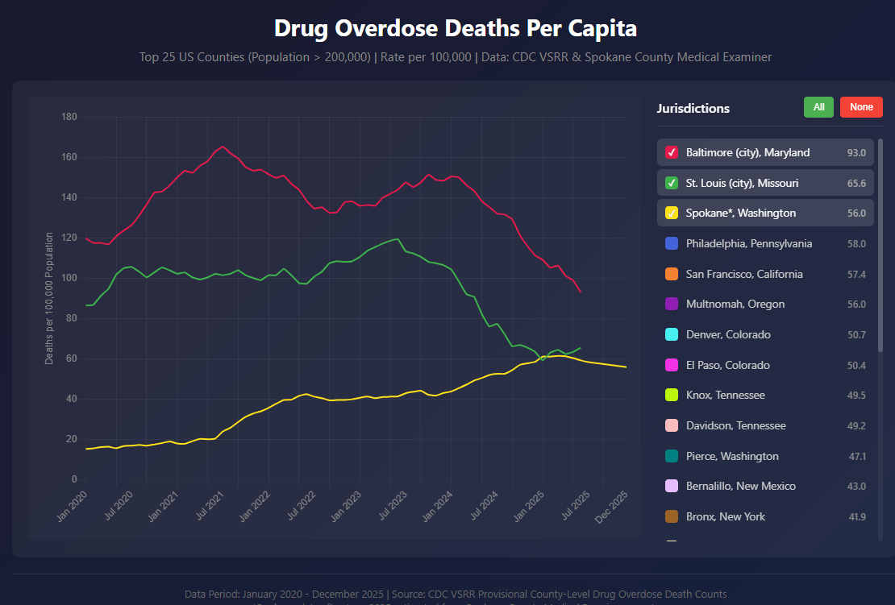

This shift matters because older low barrier service models were developed in an environment in which meals, basic shelter, and relational contact could, in many cases, provide meaningful stabilization. In the current synthetic drug environment, those same interventions may still provide immediate relief, but they are less likely by themselves to interrupt the cycle of addiction, psychiatric instability, repeated overdose risk, and chronic exposure to street conditions.
The danger is compounded by the fact that this is not a static crisis. Federal public health and law enforcement sources continue to describe an illicit drug supply that remains highly unpredictable and is constantly changing in composition. Fentanyl is increasingly mixed with tranquilizers, sedatives, and other synthetic substances, meaning that users often do not know what they are consuming and communities are not responding to a settled problem so much as a moving target. That makes passivity especially costly. A service model that was already mismatched to current conditions can become even more outdated as the drug supply evolves further.
The synthetic opioid era also appears to have altered the older idea of “rock bottom.” In prior drug eras, even severely addicted individuals often retained more intermittent agency, longer planning horizons, and a somewhat greater ability to respond to mounting consequences before death intervened. Fentanyl and related synthetics, especially when combined with methamphetamine, appear to compress that interval dramatically. Addiction can become so chemically overpowering, behaviorally disorganizing, and rapidly lethal that the person's practical capacity to self-correct is sharply diminished before traditional consequences have time to work. In that environment, waiting for rock bottom is often less a pathway to recovery than a pathway to neurological deterioration, medical crisis, victimization, or death.
This distinction is critical. In current conditions, there is a substantial difference between temporary relief and meaningful movement toward stabilization and recovery.

Low barrier services remain necessary
Nothing in this review suggests that Spokane no longer needs low barrier services. To the contrary, low barrier access remains important, likely more than ever, especially for engaging people who are medically fragile, actively using substances, deeply distrustful of institutions, or otherwise unlikely to access help through more formal entry points.
Current public health guidance supports this conclusion. Low barrier models are widely recognized as a necessary means of engaging individuals with substance use disorders and unstable housing. Washington State's Health Engagement Hub concept is relevant here because it combines low barrier access with medical care, treatment connection, harm reduction, and social supports in a coordinated setting.
The issue, therefore, is not whether low barrier services should exist. The issue is whether low barrier services should continue to operate as isolated, attraction-based, weakly integrated service points in highly fragile downtown locations, or whether they should be redesigned as part of a broader system built to move people toward treatment, stabilization, shelter, housing, and reduced overdose risk.
Low barrier should mean easy access and humane engagement. It should not mean low coordination, low accountability, or minimal connection to broader intervention pathways.
Any fair review of Shalom Ministries should begin with an acknowledgment that the individuals who volunteer time, prepare meals, and show up day after day to serve vulnerable people are carrying out acts of real kindness. They are doing more than most people do, often with limited tools, limited authority, and limited support. A warm meal, a familiar face, and a place of welcome are not trivial things, especially for people living in extreme instability.
At the same time, the reality of those acts of kindness does not resolve the larger structural questions raised in this memorandum. A ministry built around meals and hospitality cannot, by itself, create the level of integration now required in a fentanyl era street environment. It cannot on its own align treatment access, shelter navigation, behavioral health response, public order, neighborhood protection, and service siting. Those are system level functions.
For that reason, the burden of creating a more integrated response should not be placed entirely, or even primarily, on the volunteers and board members of a single ministry. Their work may need to evolve, and the present relocation moment creates an opportunity for that evolution. But the City of Spokane is the actor best positioned to make meaningful integration possible by shaping where services are located, how they are connected, what surrounding supports are expected, and how neighborhood impacts are managed.
There is a useful analogy here. When someone gives a few dollars to a person standing in a dangerous roadway median, that act usually reflects a charitable impulse, not a coherent policy judgment. The giver is responding to immediate human need with the limited means available in the moment. But it is not reasonable to expect that individual act to solve the deeper problem, and it would be unfair to place primary responsibility there. The larger responsibility lies with the city, which has the authority to disallow dangerous and harmful street conditions while also directing vulnerable individuals toward safer and more effective help. The same basic principle applies here.

Lessons from other cities
Several cities provide useful examples of how low barrier and humanitarian responses can be integrated into broader systems rather than left to function as standalone moral outposts.
San Francisco has increasingly moved toward a framework that links outreach, behavioral health, treatment demand, stabilization capacity, and stronger intervention around public drug use. The city's more recent policy direction reflects a recognition that unmanaged street conditions and purely fragmented service delivery are not producing acceptable outcomes for either vulnerable individuals or neighborhoods.
Portland, under Mayor Keith Wilson, has emphasized rapid expansion of overnight shelter and day center capacity, but with a clearer expectation that such sites be connected to broader service pathways and neighborhood management responsibilities. The model is not based simply on hospitality. It is based on using low barrier entry points to connect individuals to a larger response system.
San Antonio's Haven for Hope remains one of the clearest examples of a coordinated campus model. It combines low barrier emergency shelter with access to medical services, behavioral health support, substance use treatment, case management, and housing oriented services through a large partner network. It demonstrates that compassion and structure can coexist, and that service concentration is more defensible when embedded in a coordinated system designed to move people forward.
San Diego has developed a more layered approach that includes bridge shelters, behavioral health focused sheltering, safe sleeping models, and coordinated navigation functions. The common feature is that these are structured points of entry into a broader civic response, rather than isolated sites operating with minimal integration.
Austin offers a more mixed but still relevant case. Its recent experience illustrates the limits of fragmented and reactive systems, and the importance of aligning outreach, navigation, shelter access, treatment capacity, encampment management, and neighborhood stewardship.
Boise is also worth noting. What makes Boise relevant is not the claim that it has found a perfect solution, but that it has explicitly treated shelter siting, service integration, and neighborhood impact as questions requiring citywide planning. Mayor Lauren McLean's Shelter Better Task Force was charged with recommending how Boise should approach emergency shelters, where shelters should be located, what services they should provide, and what crisis management responsibilities they should assume. The city's broader Our Path Home system likewise emphasizes trauma informed, housing focused, data driven coordination across prevention, shelter, outreach, health, and housing services.
These examples also matter because several of the jurisdictions most often cited in current best practice discussions are not political opposites of Spokane. They are cities that, whatever their precise ideological mix, have generally moved toward more integrated, neighborhood conscious, system based responses rather than relying on isolated charitable outposts as sufficient answers in themselves.
What is striking across these examples is that cities are generally not treating isolated food lines, clothing ministries, or stand-alone day service sites as sufficient responses in themselves. The policy trend runs in the opposite direction. Basic needs are increasingly being paired with coordinated intake, housing navigation, behavioral health care, treatment access, case management, and explicit expectations regarding neighborhood compatibility. In other words, many cities appear to be moving away from disconnected charitable outposts and toward integrated systems that recognize both the needs of vulnerable individuals and the legitimate claims of the surrounding community.
Taken together, these examples do not point to a single template. They do, however, support a broader principle: in the fentanyl era, low barrier service models are more defensible when integrated into coordinated systems of treatment, stabilization, sheltering, and public realm management.

Implications for Spokane
Several implications follow from this review.
First, Spokane should continue to recognize the value of low barrier access, but should increasingly expect those services to operate as part of a broader intervention system.
Second, service configurations that generate predictable street congregation in highly sensitive locations, especially near schools, gateway corridors, or deeply stressed parts of downtown, should be reassessed. The surrounding neighborhood impact is not incidental. It is part of the overall effectiveness of the model.
Third, food, basic shelter, and hospitality remain necessary, but they are no longer sufficient as organizing principles in a fentanyl dominated street environment. Low barrier access points should be systematically linked to medication, treatment, behavioral health triage, shelter navigation, and housing pathways wherever possible.
Fourth, Shalom Ministries should not be treated as an adversary simply because its current model is subject to review. Its current search for a new location creates a rare opportunity to consider not only where the ministry should go next, but how its work might be carried out in a more integrated, sustainable, and neighborhood compatible way. The central issue is not whether help should be offered, but whether it is being offered in a form equal to present conditions.
Fifth, because the City of Spokane is best positioned to shape siting, coordination, neighborhood protection, and service integration, it should assume a more active responsibility for connecting ministries such as Shalom to a broader system of treatment, stabilization, shelter navigation, and public realm management rather than leaving those burdens to isolated charitable providers acting largely on their own.

Need for dialogue
The issues reviewed here suggest the need for a more direct and structured dialogue among ministry leaders, service providers, neighborhood stakeholders, school representatives, downtown interests, city officials, and health and treatment systems.
That dialogue should proceed with full recognition of the historical contribution and good faith of existing providers. At the same time, it should not avoid difficult questions simply because the institutions involved are well intentioned. In present conditions, seriousness of purpose requires seriousness of review.
Possible discussion prompts include the following:
1. How materially has the fentanyl era changed the population being served, the risks people face, and the effects service concentrations have on surrounding neighborhoods?
2. To what extent are existing low barrier services directly connected to treatment, medication, behavioral health triage, stabilization, and housing navigation?
3. Are current service locations still appropriate given proximity to schools, gateway corridors, and fragile parts of downtown?
4. What redesign or relocation options would better serve both vulnerable individuals and the broader community?
5. What outcomes should now be used to evaluate success: volume of meals and shelter provided, or measurable movement toward reduced overdose risk, stabilization, treatment connection, and housing progress?

Conclusion
The strongest conclusion supported by this review is straightforward: Spokane continues to need low barrier services, but the current era requires those services to be delivered in a more integrated, clinically connected, and geographically thoughtful manner than many legacy models were originally designed to provide.
This is not a rejection of the charitable vision that gave rise to Shalom Ministries or to similar ministries serving vulnerable people. It is a recognition that changed conditions may require changed methods if those ministries are to remain fully faithful to their underlying purpose.
The most constructive next step is twofold. First, as Shalom Ministries considers relocation, it should undertake a deliberate review not only of where the ministry will operate next, but of how its mission can be carried out in a form better aligned with present conditions. That review should include serious consideration of co location with other services, or other forms of practical integration, that could connect meals and hospitality more directly to treatment, stabilization, shelter navigation, and broader support. Co location is not the only possible path, but it is one of the clearest ways to move from relative isolation toward a more coordinated model.
Second, the City of Spokane should not remain a bystander to this process. Because the city is uniquely positioned to shape siting, service coordination, neighborhood protection, and system integration, it should work more directly with Shalom Ministries as this transition unfolds. Whether that engagement is initiated by Shalom, by the city, or by both, it should happen. The present moment creates a rare opportunity to connect a longstanding charitable ministry to a more integrated civic response, and that opportunity should not be lost.
If that review and engagement occur in good faith, this moment could become more than a relocation. It could become the beginning of a stronger next phase for Shalom Ministries, one that preserves the ministry's core kindness while placing it within a structure better suited to the fentanyl era, better for the people it serves, and more compatible with the health of the surrounding community.

Attachment A: Background on Selected Downtown Spokane Low Barrier and Drop-In Service Providers
This attachment provides brief background on selected downtown Spokane providers to clarify that the downtown service landscape is varied and that not all low barrier or drop in programs are similarly situated. The main memorandum focuses on Shalom Ministries because of the combination of its current relocation decision, its location next to Lewis and Clark High School, the apparent scale of its adult meal centered model, and the opportunity this moment presents to consider a more integrated and better sited next phase.
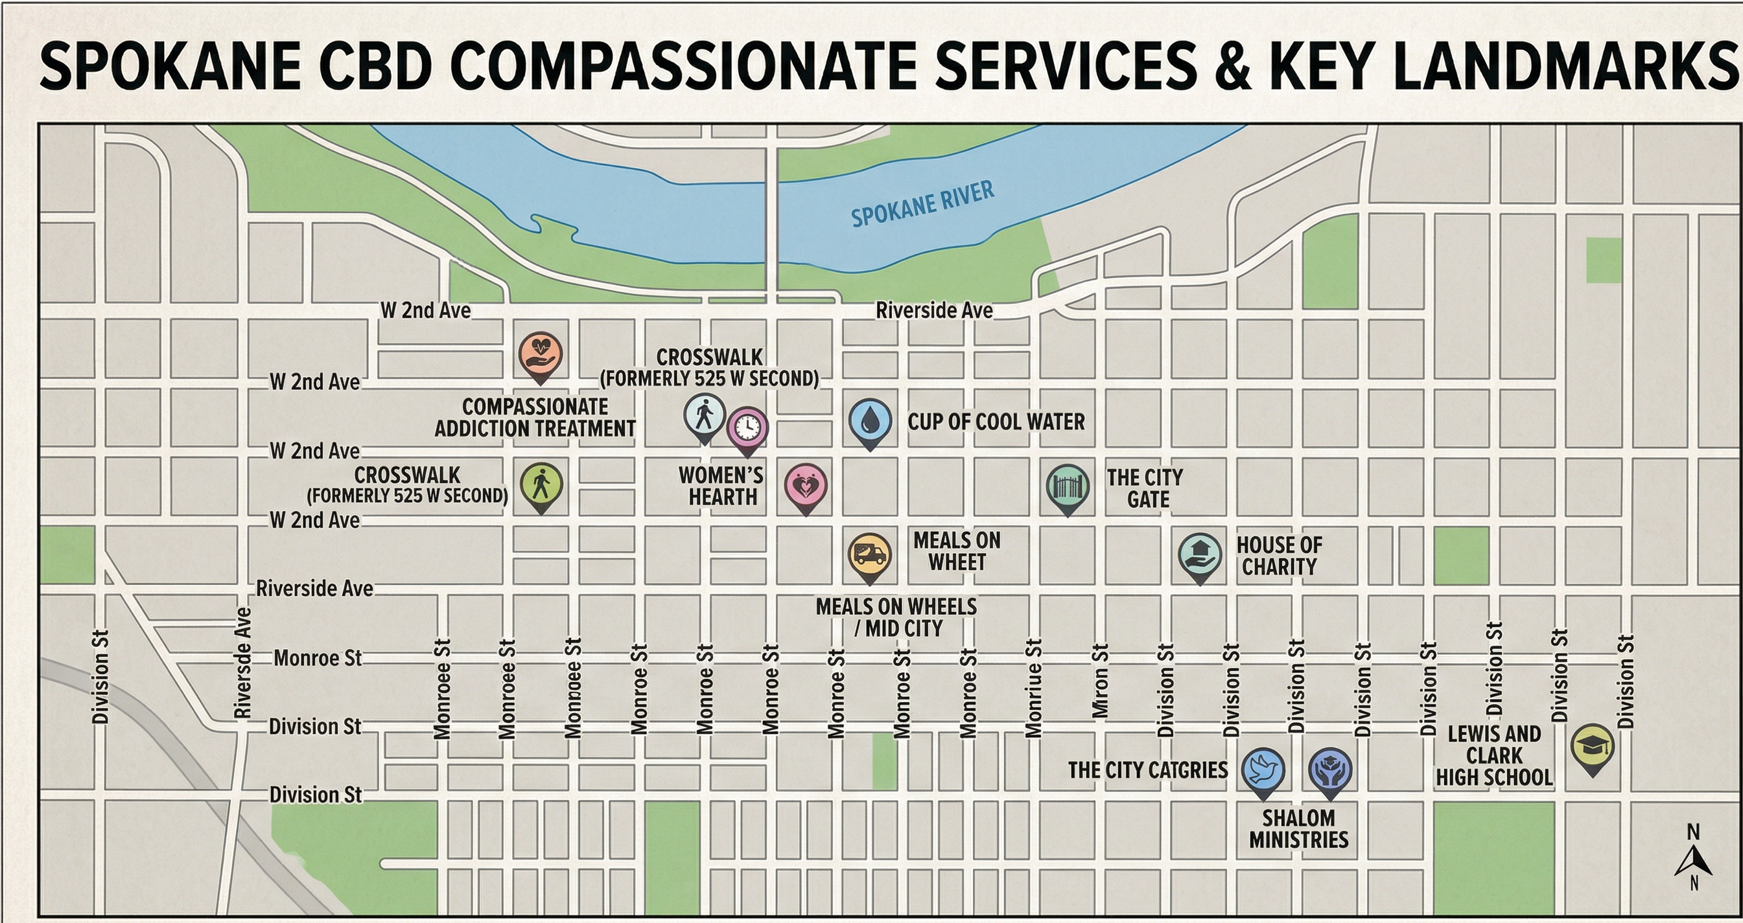

Shalom Ministries
Shalom Ministries traces its Spokane roots to meal service work in the 1970s and 1980s and became a separate nonprofit in 1994. It operates at 518 W. 3rd Ave. in New Community Church and reports serving more than 84,000 meals annually. Publicly available materials also describe a Pathways program through which accepted participants receive job and life skills training, case management, mentoring, housing assistance, and a monthly stipend. At the same time, the public record does not make clear the current scale of Pathways relative to the larger meal operation. Shalom has also publicly stated that New Community Church has put the building up for sale and that the ministry needs a new home, making this an especially timely moment to consider not only where Shalom should go next, but how its next phase should be structured.

Catholic Charities’ House of Charity
Catholic Charities' Spokane work dates to 1912, and House of Charity has operated since 1958. In addition to meals and shelter, House of Charity has included case management and a respite component. Catholic Charities' published House of Charity 2.0 materials state that the current site at 32 W. Pacific would remain in use, but would no longer sleep or feed people experiencing homelessness if the transition proceeds. Catholic Charities has described a move toward a more private, trauma informed, service enriched approach, making House of Charity an important example of a provider already undertaking structural adaptation. For that reason, it remains relevant to the analysis, but is not the main focus of the present memorandum.

The City Gate
The City Gate, now closed, remains relevant as a cautionary historical case. Reporting after its January 2025 closure described it as a downtown ministry created in 1988 that provided food, clothing, spiritual support, social services, low cost housing, and emergency shelter over many years. At the same time, it became a focal point for neighborhood complaints and concerns about unmanaged disorder around the site. The City Gate is included not as a current subject of reform, but as a reminder that charitable models that may once have served a valuable purpose can become increasingly difficult to defend when they operate in a changed street environment without sufficient neighborhood compatibility or integration.

Meals on Wheels Spokane / Mid-City Senior Center
Meals on Wheels Spokane appears materially different from Shalom in both target population and service design. Its public materials emphasize home delivered meals for elderly, disabled, and homebound seniors, and state that the organization has served that population since 1967. Meals on Wheels Spokane also operates the Mid City Senior Center at 1222 W. 2nd Ave., including weekday senior lunch service. Because much of the program is meal delivery to a defined senior population rather than an unrestricted adult congregation model, it should not be assumed to present the same questions addressed in the main memorandum.

Cup of Cool Water
Cup of Cool Water operates at 1106 W. 2nd Ave. and serves youth and young adults experiencing homelessness, with public materials describing hot meals, showers, clothing, laundry, referrals, mentoring, workforce development, and other supportive programs. Its drop in services are bounded by age, and it appears more integrated than a simple food line. That does not answer every neighborhood impact question, but it does suggest that it should not automatically be treated as equivalent to a high volume, adult all comers meal ministry.

Women’s Hearth
Women's Hearth, part of Transitions, is another downtown provider that appears structurally distinct from Shalom. Public materials describe it as a day center serving women, trans women, and nonbinary individuals, with food, showers, support groups, classes, referrals, and housing search case management. Like Cup of Cool Water, it serves a narrower clientele and appears to offer a broader support structure than a stand alone meal centered model. It belongs in the downtown service landscape, but not necessarily in the same analytical category as Shalom.

Crosswalk, as a Local Siting Example
Crosswalk is not included as a direct parallel to Shalom, but it is a valuable Spokane siting case study. Volunteers of America has stated that its former downtown location at 525 W. 2nd Ave. had become increasingly dangerous and that the building could no longer support the services youth needed. In describing the move, VOA emphasized the value of a setting away from the stress of downtown and closer to schools, green space, health services, and expanded program capacity. This matters because it shows that local providers themselves recognize that location and surrounding street conditions materially affect client outcomes.

Compassionate Addiction Treatment, as a Local Location Case Study
Compassionate Addiction Treatment provides a useful local example of how service effectiveness and siting can be considered together. CAT previously operated at 168 S. Division Street and now operates at 960 E. 3rd Ave. Public materials indicate that CAT continues to provide outpatient treatment, medication for opioid use disorder, peer support, housing and employment case management, and navigation services at the new site. Whatever one thinks of every detail, CAT's current location on the east edge of downtown suggests that it is possible to preserve access to care while reducing the concentration of collateral neighborhood burden in already stressed corridors. That makes CAT relevant not as a direct analogue to Shalom, but as a local case supporting the memorandum's broader point that thoughtful siting matters.

Attachment B: Comparative Snapshot of Selected Downtown Spokane Low Barrier and Drop-In Providers
This table provides a comparative snapshot of selected downtown Spokane providers and explains why the main memorandum focuses on Shalom Ministries for now.
Provider | Address / area | Founded / history | Primary clientele | Barrier level | Public scale / hours
Shalom Ministries | 518 W. 3rd Ave. | 1994 nonprofit; meal roots in 1970s–80s | Broad adult population in need | Very low barrier for meals | 84,000+ meals annually; meal windows publicly emphasized
House of Charity | 32 W. Pacific Ave. | Catholic Charities Spokane since 1912; HOC since 1958 | Adults experiencing homelessness | Low barrier shelter model | Current site active, but transition underway
The City Gate | Former downtown site | Created in 1988; closed in 2025 | Broad homeless / low-income adult population | Historically low barrier | Operated for decades before closure
Meals on Wheels / Mid-City | 1222 W. 2nd Ave. | Since 1967 | Seniors, especially homebound seniors | Not an all-comers model | Home delivery plus weekday center lunch
Cup of Cool Water | 1106 W. 2nd Ave. | Longstanding youth service provider | Youth and young adults, roughly 14 to 24 | Low barrier, but youth-bounded | Drop-in hours publicly listed
Women’s Hearth | 920 W. 2nd Ave. | Longstanding Transitions program | Women, trans women, nonbinary individuals | Low barrier day center for defined population | Weekday programming publicly described
Crosswalk | Formerly 525 W. 2nd Ave.; moved east | Local youth shelter | Homeless and vulnerable youth | Youth-specific | Expanded new facility east of downtown
Compassionate Addiction Treatment | Now 960 E. 3rd Ave.; formerly 168 S. Division | Recent local relocation example | People with substance use disorders | Low barrier addiction treatment | Current programs publicly listed
Continuation of Attachment B
Provider | Core services | Apparent integration | Neighborhood relevance | Relevance to main memo
Shalom Ministries | Meals, Pathways, mentoring, case management, housing help, stipend | Some integration through Pathways, but public scale is unclear | Adjacent to Lewis and Clark; fragile downtown corridor; building for sale | Primary focus
House of Charity | Shelter, meals, showers, case management, support services | More integrated and already restructuring | Major corridor and gateway impacts | Secondary context
The City Gate | Meals, clothing, social support, low-cost housing, shelter | Public record suggests relatively stand-alone model | Became focal point for complaints | Historical caution
Meals on Wheels / Mid-City | Home-delivered meals, senior center lunch | More bounded, specialized model | Downtown address, but very different population and pattern | Not central
Cup of Cool Water | Meals, showers, clothing, laundry, mentoring, workforce development | More integrated than a stand-alone meal line | Downtown site, but distinct clientele and structure | Not central
Women’s Hearth | Food, showers, groups, referrals, housing-search support | Programmatic and support-oriented | Downtown site, but bounded and more service-rich | Not central
Crosswalk | Shelter and youth supports | Structured youth model | Provider cited downtown danger as a reason to move | Siting case study
Compassionate Addiction Treatment | Outpatient treatment, MOUD, peer support, case management, navigation | Highly integrated compared with meal ministry | Shows value of buffered, edge-of-downtown siting | Local location case study

